Lab Consortium Wiki Instructions

**Getting Started**

* First, you need to create a wikispaces account. Accounts can be created at the following URL: <https://www.wikispaces.com/user/join>
* Enter a username, password and your email address and click “No” for “Make a wiki”:

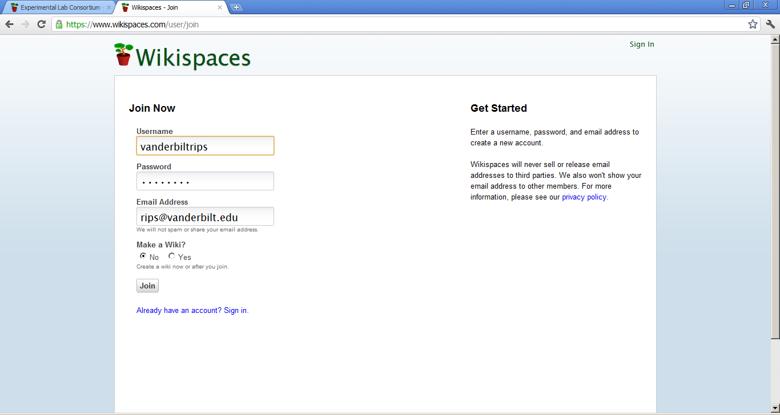

* Wikispaces will send a confirmation email to the email address you have provided. You must click the confirmation link in that email to confirm your account. After that, your account is officially registered.

**Joining the Lab Consortium Page**

* Go to the Lab Consortium wiki homepage (<http://labconsortium.wikispaces.com/>)
* Click “join” on the left hand side of the page

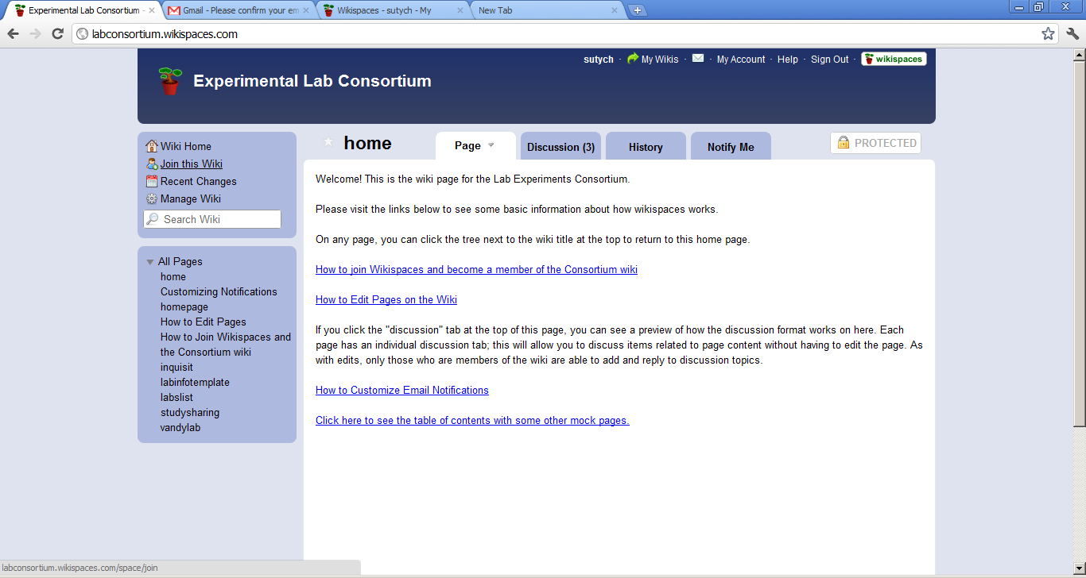

* Enter your name and institution as the “comment” on the join page and click “Request Membership”

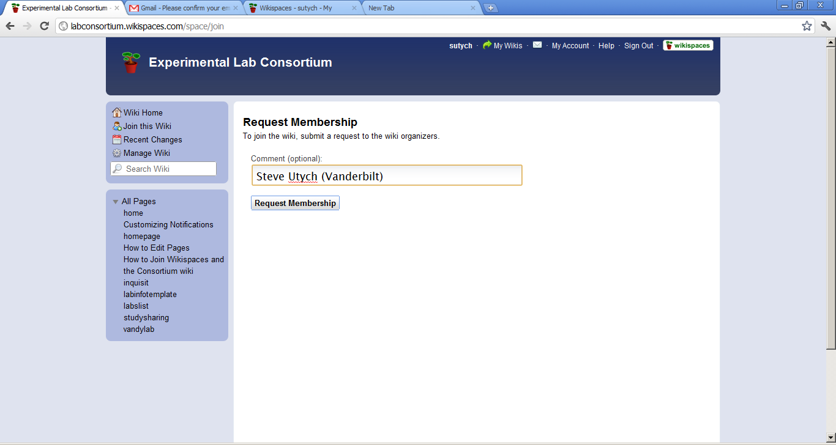

* Your membership will then have to be confirmed by the organizers of the wiki. This will be done as quickly as possible. You will be notified via email once your membership has been confirmed. Once the membership is confirmed, you will be able to edit the wiki when you are logged in to wikispaces. Anybody, regardless of membership, will be able to view the wiki.

**Editing Notification Settings**

* When you log-in to Wikispaces, you are taken to your “Dashboard.” This can also be accessed by clicking on your user name on the upper right of any wikispaces page, or by going to the following URL: <http://www.wikispaces.com/user/my/steveutych> (replacing “steveutych” with your username)
* From there, you will notice 3 tabs at the top: “Dashboard,” “Mail,” and “Settings.” Click on the “Settings” tab.
* At the top of the settings page, you can change information such as your username, email address and password, or edit your profile and add a picture if you’d like to.

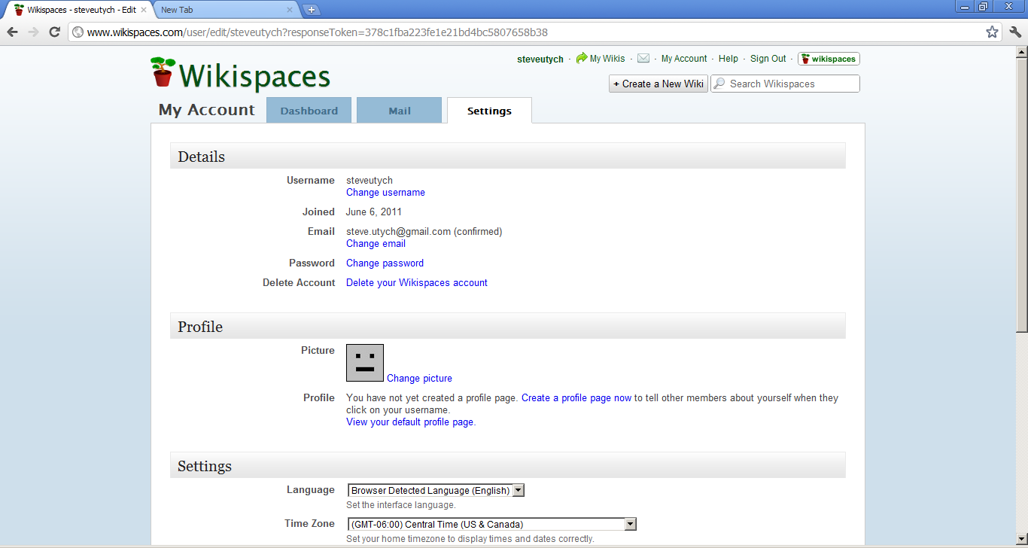

* Under the “Settings” section, you can edit the types of emails you receive. I have included a screenshot below of how this should look to enable messaging from other members of the wiki and receiving a daily digest of changes made to the wiki. If you wish to not receive private messages, or receive more frequent email updates or none at all, you can change this via the appropriate dropdown menu.

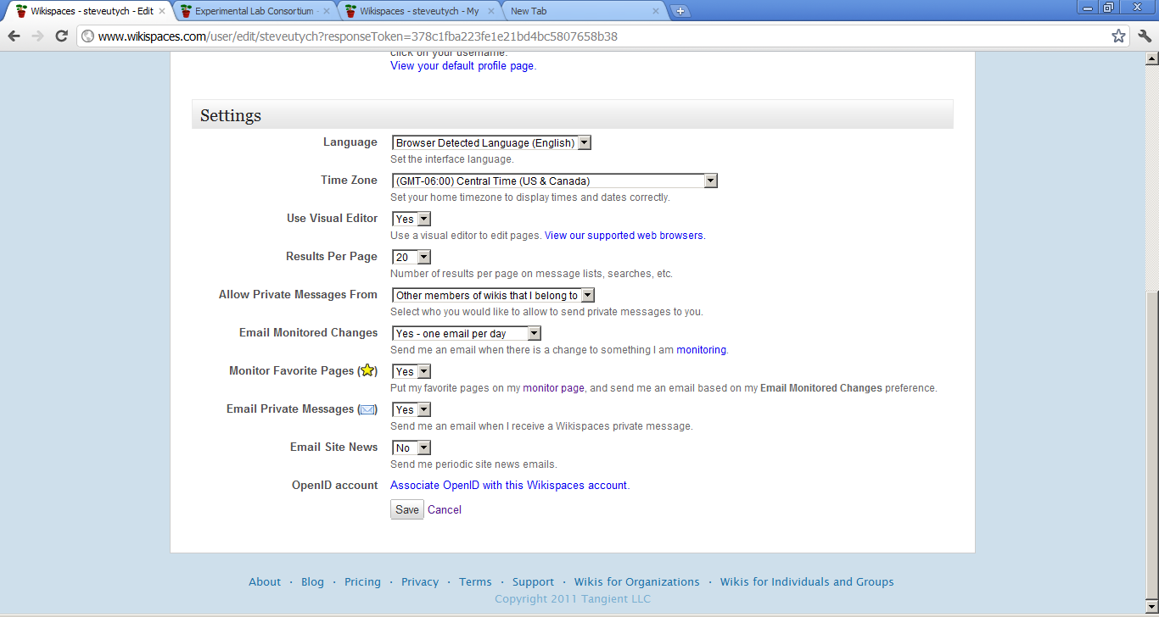

Change this to YES to receive email notifications (Default is NO)

* To finalize notification settings, go to the following URL to set your subscription status to the lab consortium wiki <http://labconsortium.wikispaces.com/wiki/notify>
* Once there, you will notice that all 3 available check boxes are empty. Click each one if you wish to receive notifications about the wiki. “Page Edits” will notify you about any page in the wiki that has been changes. “Discussion” will notify you of a new discussion post made by a wiki member on the wiki. “File Changes” will notify you if a new file has been uploaded. I recommend checking “Page Edits” and “Discussion,” as any uploaded files will be placed on a page within the wiki and can be found there. Click “Update” once the appropriate boxes are checked to change notification settings (This does not need to be done if you wish to receive no email notifications)

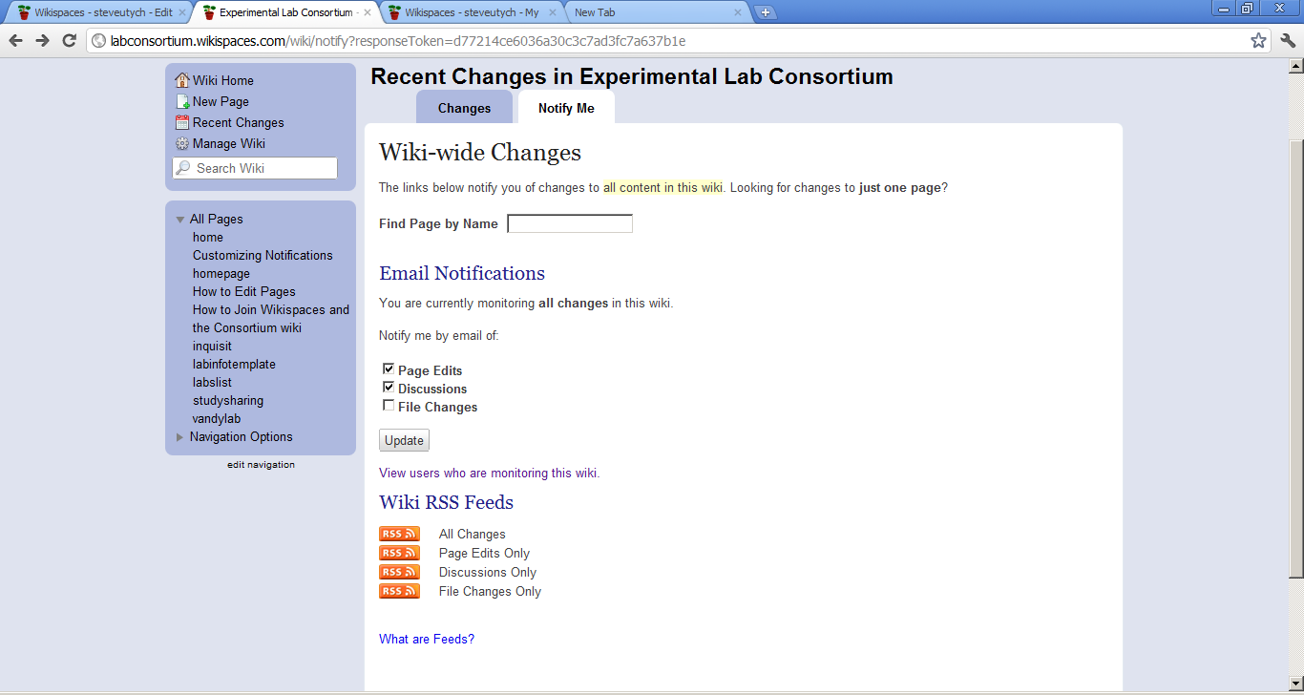

**Editing the Wiki**

**Editing an Existing Page**

* When you are on the page you want to edit, click the “Edit” icon in the upper right corner of the page:

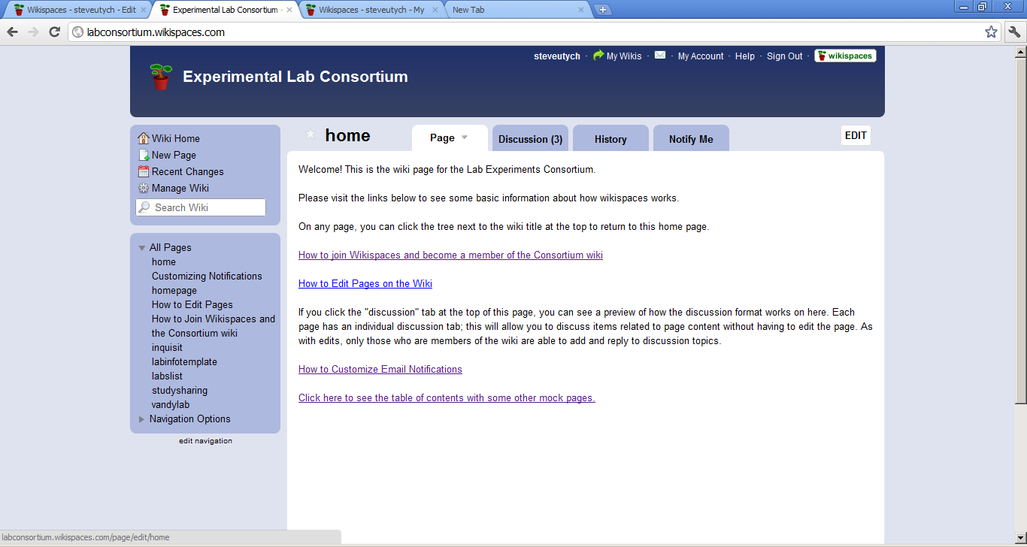

* This will bring up a text editor with a toolbar on top. From there, you can simply type in the text you wish to add or edit and insert files from the menus at the top.

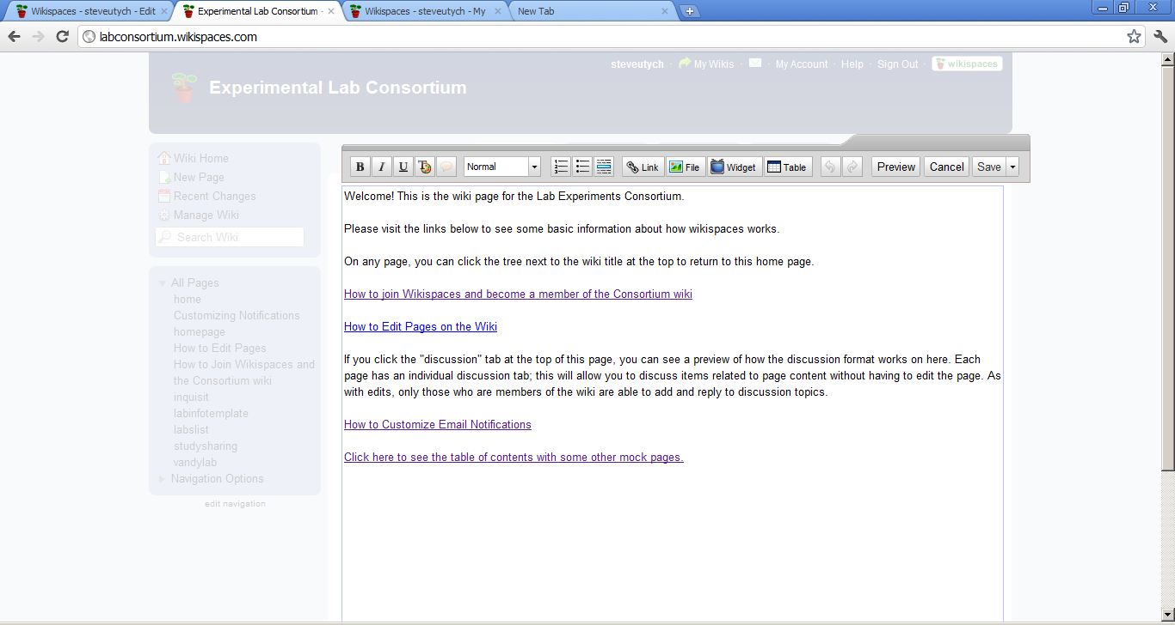

* When you are finished editing, click the “Preview” button on the editing toolbar. This will bring up a preview of your changes to the page:

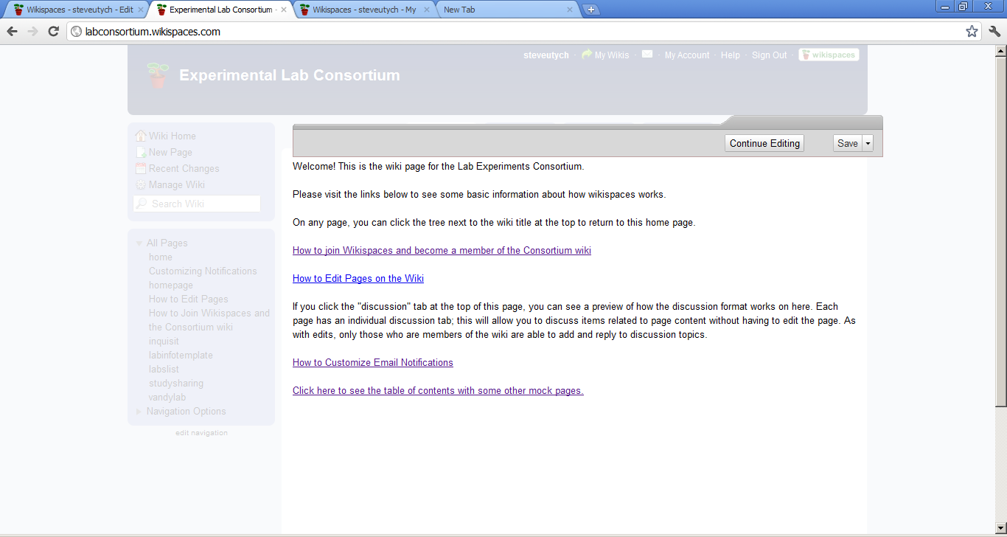

* If you would like to make more changes, click “Continue Editing” at the top. If you are satisfied with your changes, click “Save” – this will make your changes to the page active.

**Adding pictures, links and other “extras” (To do any of the below tasks, you must have the page editor active as described above)**

* To add a link, click the “link” icon at the top of the editing toolbar
* This default setting on the link window is adding an internal link to another page on the wiki. To add an internal link, add the text you want to appear in the wiki on the “Link Text” box. Do not change the content in the “Wiki” text box. On “Page Name,” use the dropdown menu to select the page to link to. In the below example, I am creating a link that says “Return to Home Page” on the page; this link will take you to the Lab Consortium Wiki main page when clicked. Once you’ve done this, click “add link” and your link will show up in the text editor as it will appear on the page.

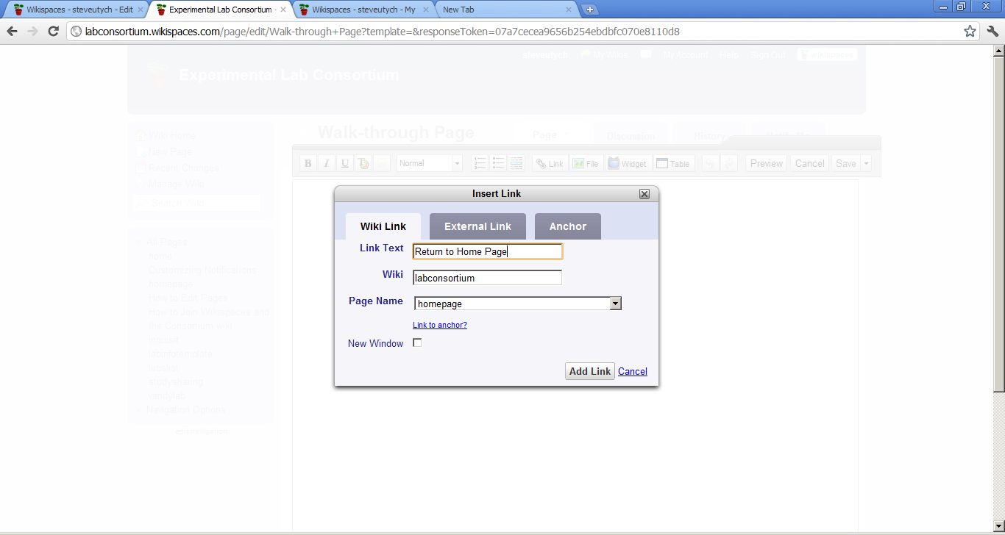

* To add a link to an external website, click the “Link” button on the editing toolbar. When the link window opens, it will default to a Wiki Link. Click the middle tab that says “External Link.” From there, you will add Link Text as you would for a Wiki Link. Under “Address,” enter the URL you wish to link to. Click “Add link” when you are finished. In the below example, I created a link to [www.google.com](http://www.google.com) that will display as “Google.”

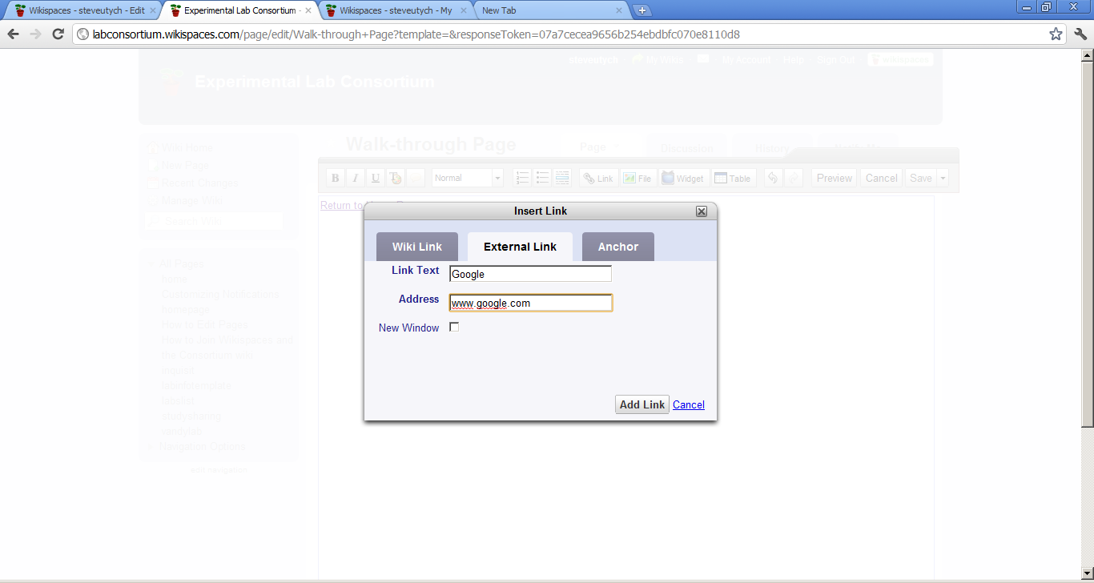

**Inserting a file**

**Creating a New Page**

* Click “New Page” on the right of any of the pages on the wiki. This will bring up a page like the one below to create a new page. Give the page a title that refers to the content of the page. For example, if you are creating a page about your lab, put something such as “vandylab.” Secondly, you can add “tags” to the page. This will allow people to search the wiki and find your new page more easily. To add tags, type short descriptors of what your page is about. Separate each tag with a comma. Once you’ve named your page and added tags, click “Create” to make the new page.

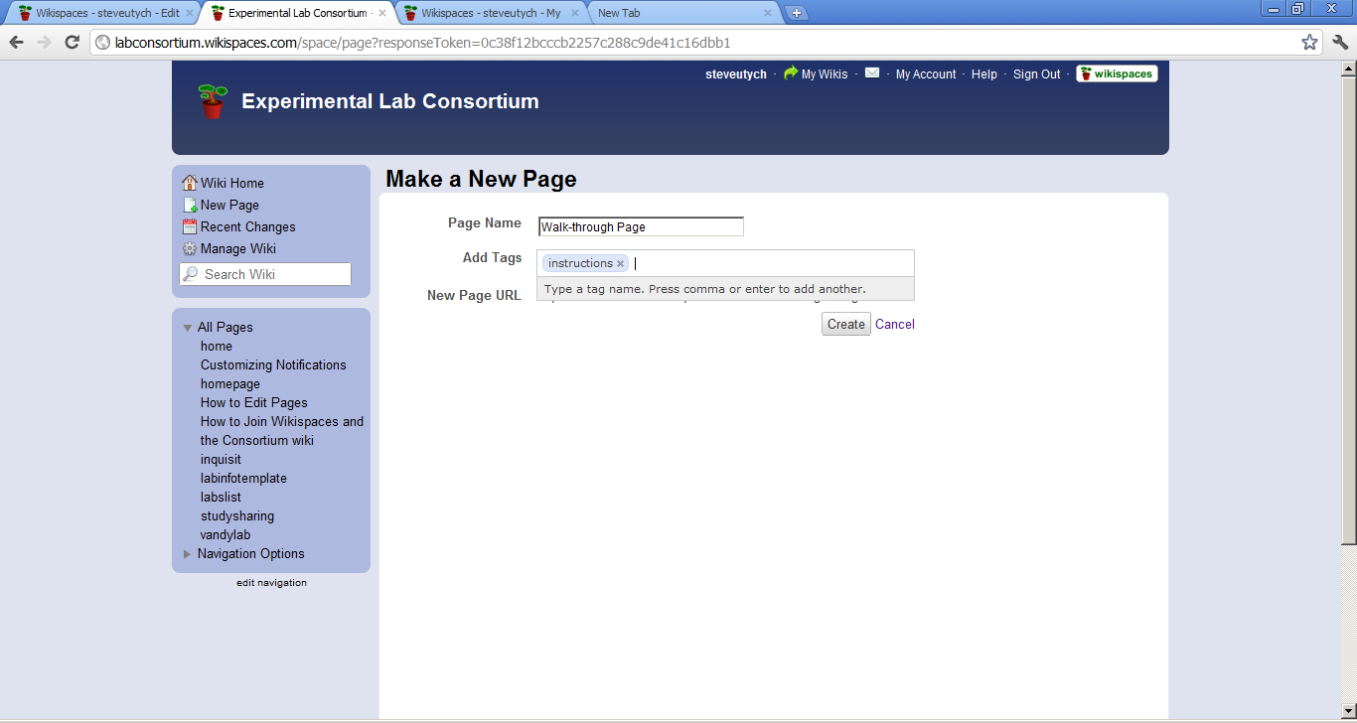

* Once you have created the new page, you can edit it as you would an existing page.